**Enable Substitution With Interfaces**

|  |  |  |
| --- | --- | --- |
| *a driver class has become cluttered due to support for various server implementations* |  | *line up the abstractions behind these variations using interfaces* |

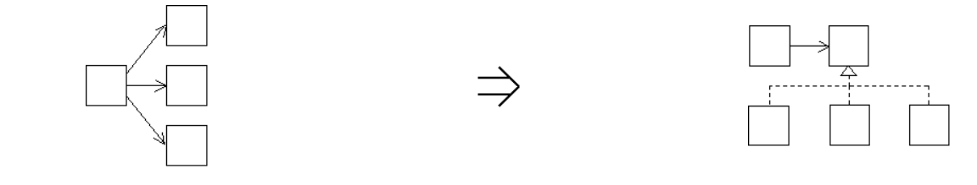

**Context:**

[Enable Substitution With Interfaces](https://web.archive.org/web/20090914101002/http:/www.refactoring.be/thumbnails/rtn-eswi.html) is a special case of [Separate Interface From Implementation](https://web.archive.org/web/20090914101002/http:/www.refactoring.be/thumbnails/rtn-sifi.html) where the introduction of an interface allows different implementations to be substituted thus improving the reusability of the client code.